COS30043 - 6.2 D HD - Custom Web Application Report
Author: Ta Quang Tung - 104222196
This report describes the HD-level custom web application that I have made for task 6.2 D HD. It is a social media application made with Vue and Vuetify that interacts with a custom backend.

Functionality
The social media application allows users to create accounts, share posts, and interact with others. They can sign up, log in, and log out of the system with an accessible user interface. After creating an account, a user can then create posts on their timeline. Posts can have text and photos and can be edited or deleted. Users can also search for and send friend requests to others on the platform. A friend request can be either accepted or declined. If it is accepted, the users officially become friends and their posts will appear on each other’s news feed. Users can react (like/dislike) to other posts and view the number of reactions for each post.
A video demonstration of the application can be seen on this link. Below are some screenshots that showcase the aforementioned features:
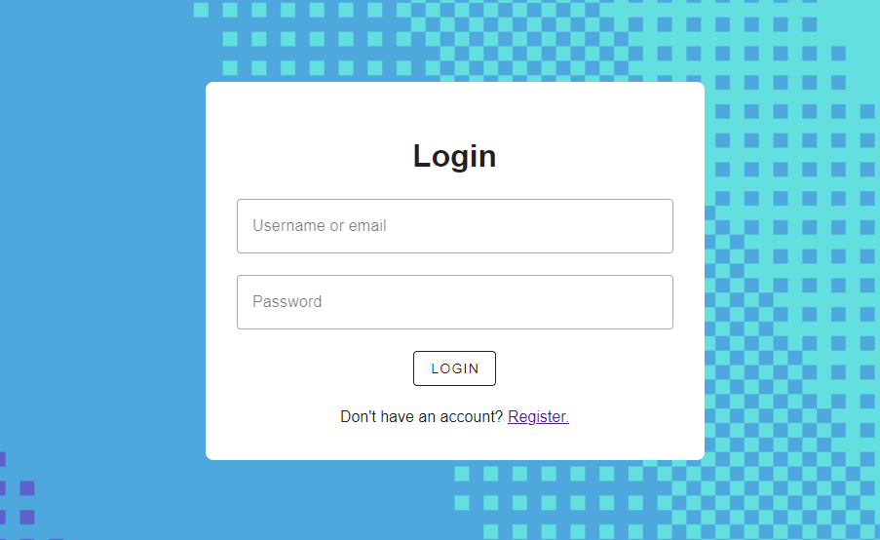
Fig. 1: The login screen.
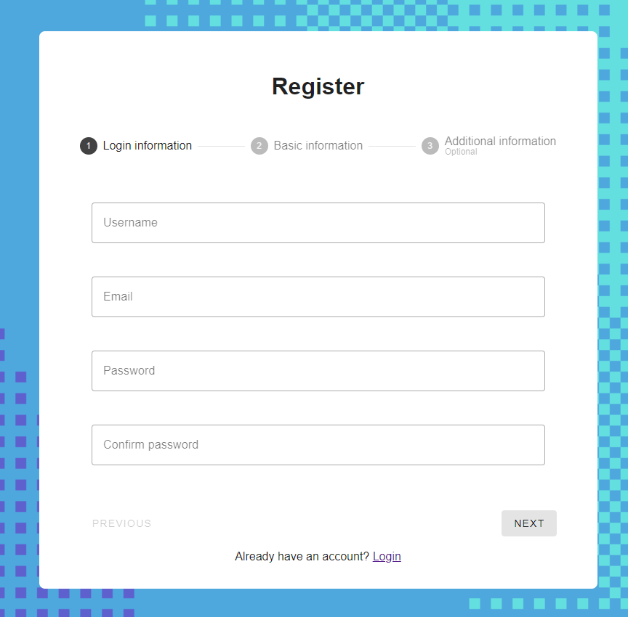
Fig. 2: The register (sign up) screen.
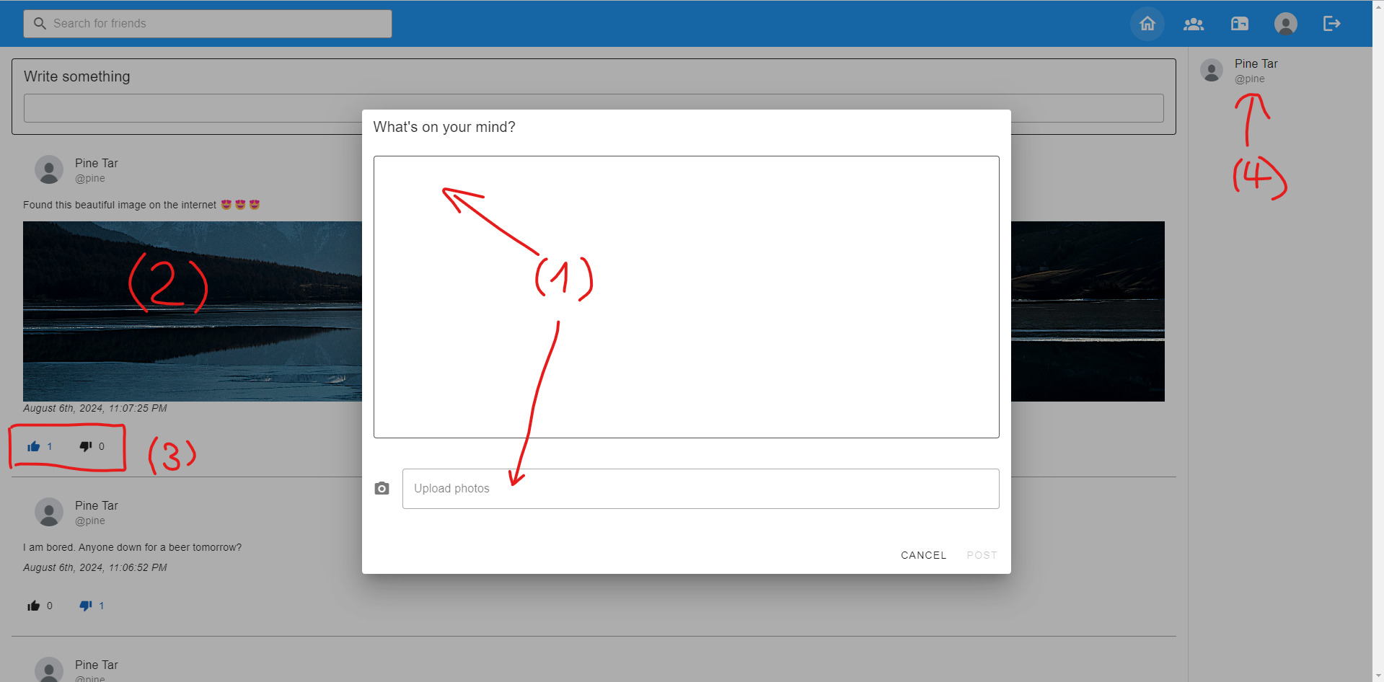
Fig. 3: The application’s homepage after the user has logged in. It shows various features in action: (1) a post upload form that allows text and photo media entry, (2) the news feed with various posts, (3) the post reaction feature, and (4) the list of friends of the user.
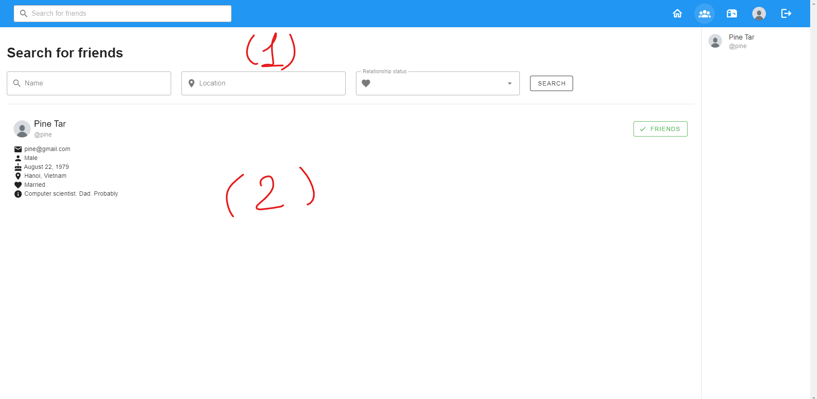
Fig. 4: The “Find Friends” page. It currently shows a list of other users in the system (in this case only 1). Also notice that there are various search filters that help to narrow down the search.
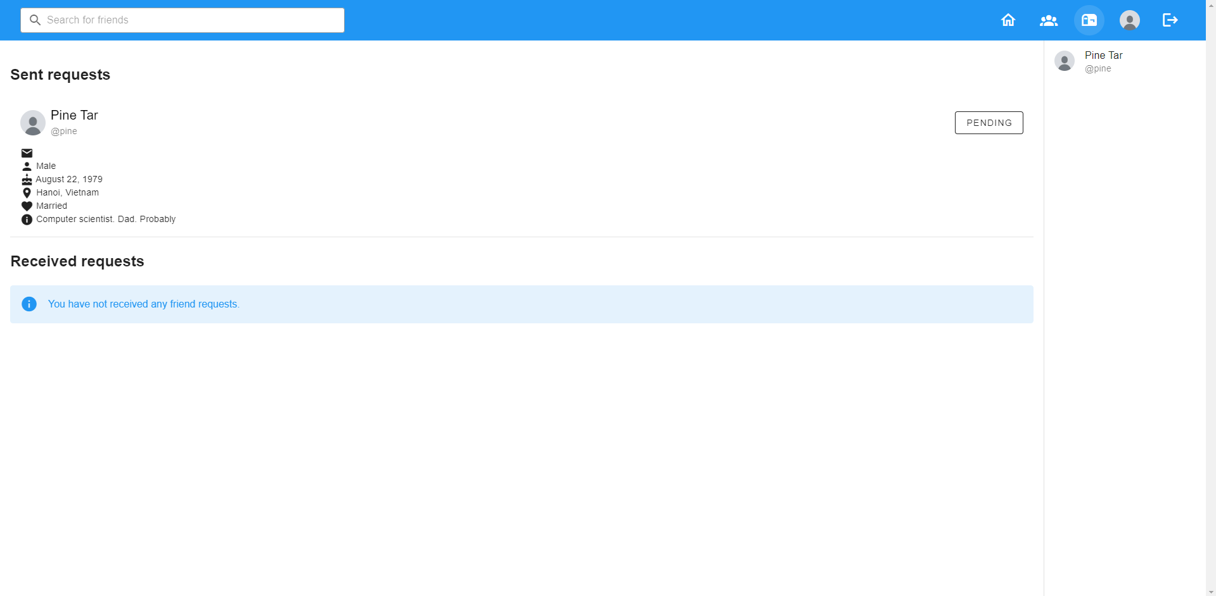
Fig. 5: The “Request Inbox” page. It shows a list of friend requests sent and received by the current user.
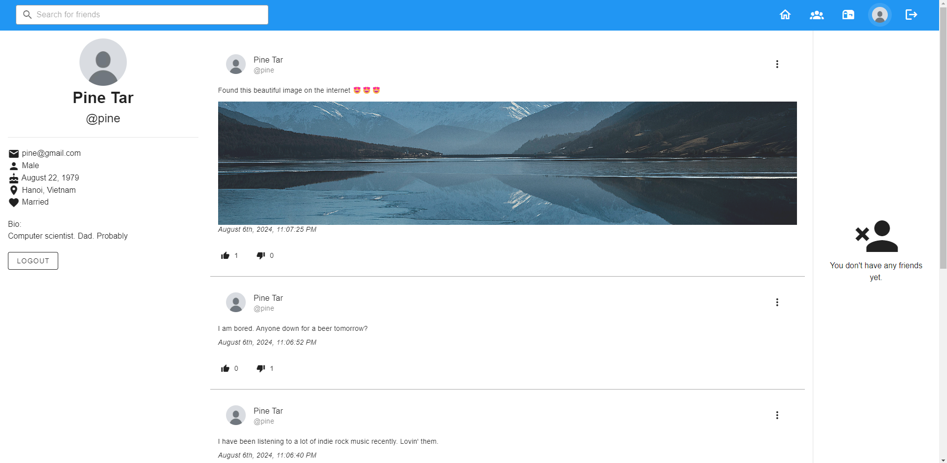
Fig. 6: The “User Profile” page, which shows the user’s information and their posts sorted in reverse chronological order.

Technical aspects
The full code for the project is available on the following GitHub repository: https://github.com/pine04/cos30043-tmt.
The frontend of the web application was built with Vue.js (Composition API style) and Vuetify 3. Using Vuetify greatly speeds up the design process and ensures that the application meets accessibility guidelines as it is an implementation of Google’s Material Design. In addition to this, the frontend also uses Vue-Router for client-side routing and Pinia for the client data store.
The frontend uses JavaScript’s Fetch API to interact with a custom backend written in Express.js. It stores user data on a MySQL database and user media files on a local MinIO bucket (which is similar to an AWS S3 bucket but on localhost). Detailed instructions on how to set up both the frontend and backend can be found in the above repository.

Innovative features
The social media app has a number of advanced UI components such as infinite scrolling (for the news feed), steppers (for the registration process), and image carousels (for viewing the posted photos). These features help improve the application’s usability and performance. Most notable of these is the infinite scrolling feature, which is a staple of many social media applications. This feature allows posts to be loaded automatically in small batches at a time, preventing unnecessary server fetches and making the user interface faster.
Another innovative feature this application has is the use of Pinia to manage authentication state on the client. As the authentication state is a global piece of state, passing it down through props makes for highly unreadable code. By capturing this information and related functions that manipulate it in a Pinia store, this state can be shared more effectively and elegantly across the application.

